UNICO Assignment

Contents

GlassFish Deployment 3

ActiveMQ Console 4

Restful Web Services 4

Push Operation 4

List Operation 5

SOAP Operations 6

GCD 6

GCD List 7

GCDSum 7

Load Testing 8

# GlassFish Deployment

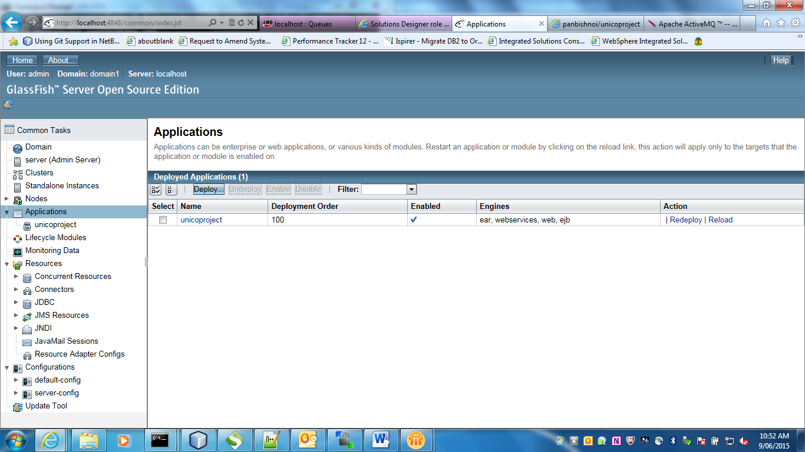

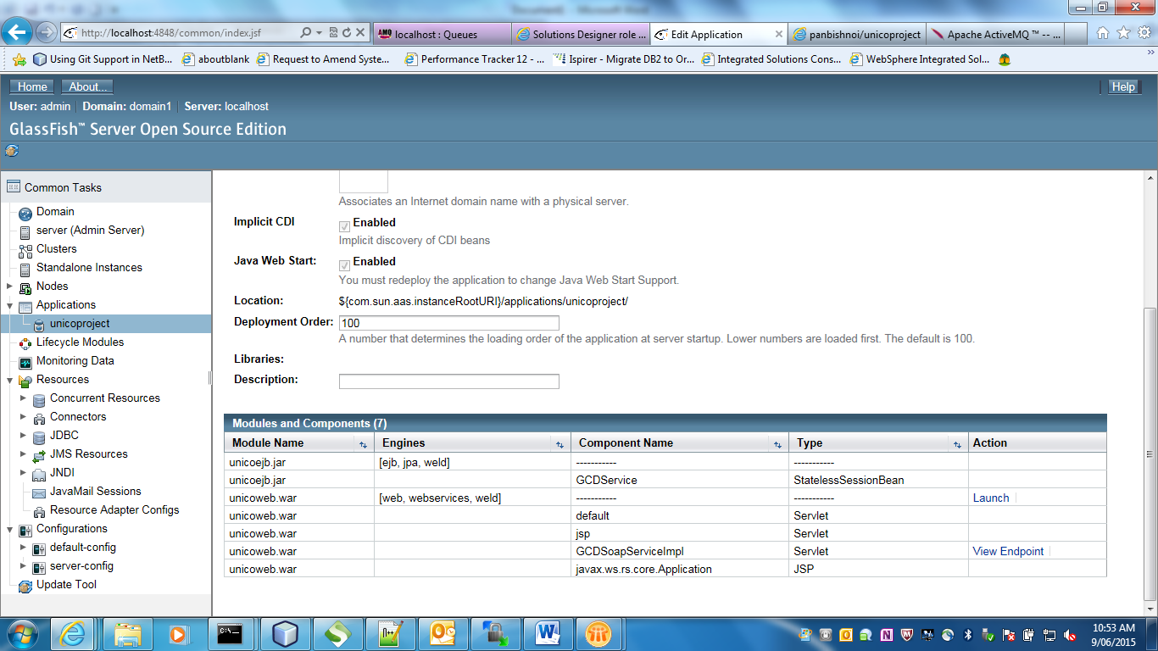

# ActiveMQ Console

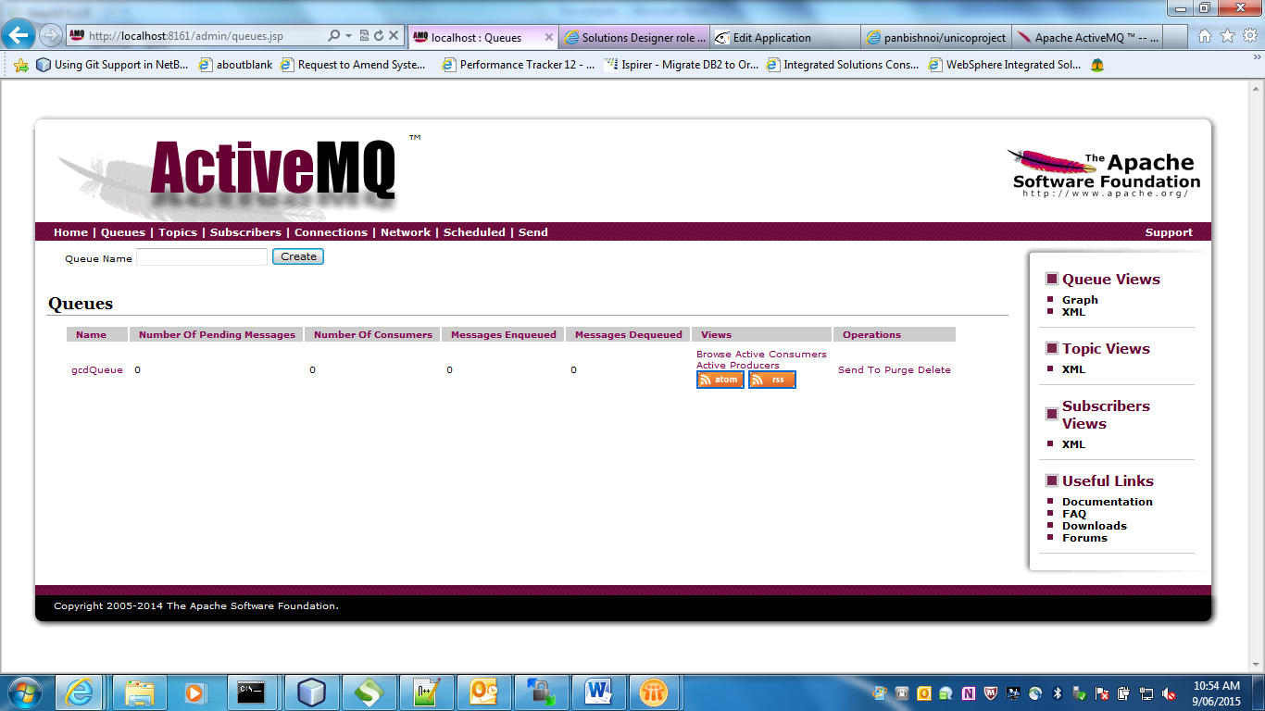

# Restful Web Services

## Push Operation

<http://localhost:8080/push/20/30> --Post

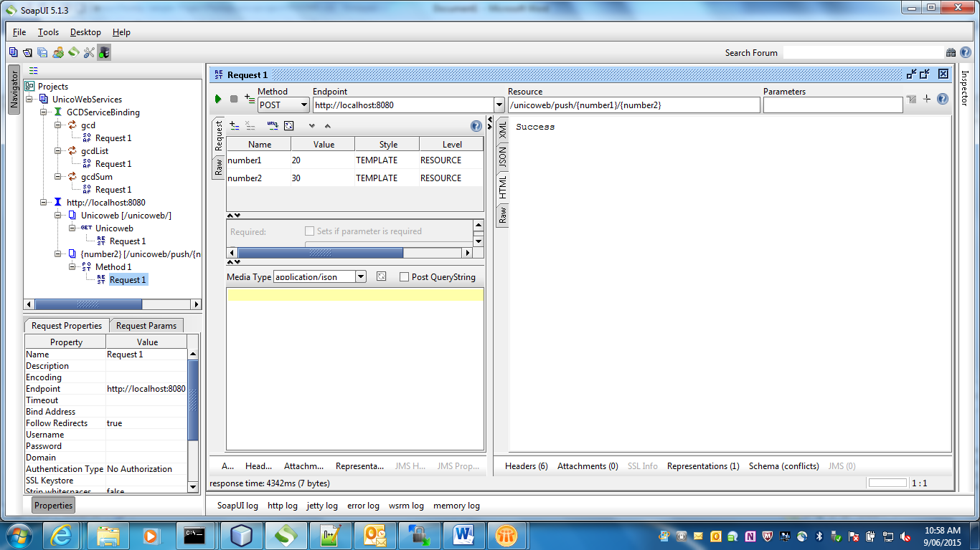

Both 20 and 30 have been added to gcdQueue this can be validated by going to ActiveMQ console as shown below

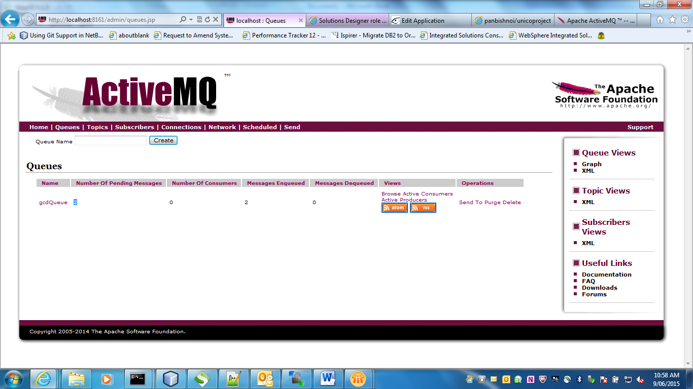

## List Operation

<http://localhost:8080/unicoweb/> --Get

This operation returns list of integers submitted for GCD calculation from database table EnteredNumbers as JSON list.

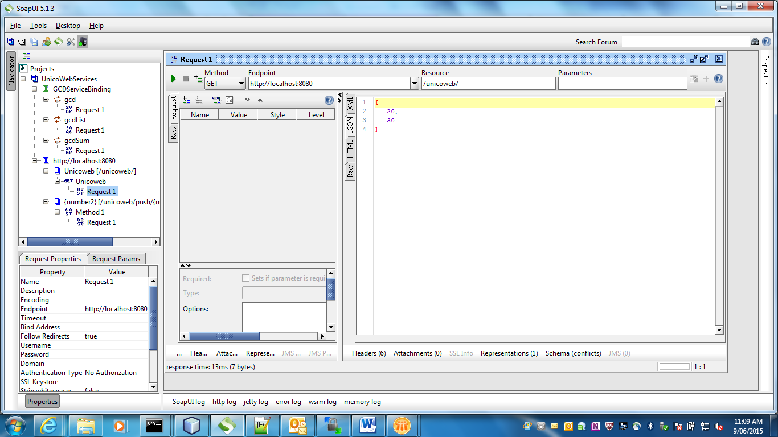

# SOAP Operations

## GCD

This returns the greatest common divisor* of the two integers at the head of the gcdQueue.

These elements will subsequently be discarded from the gcdQueue and the head replaced by the next two in line.

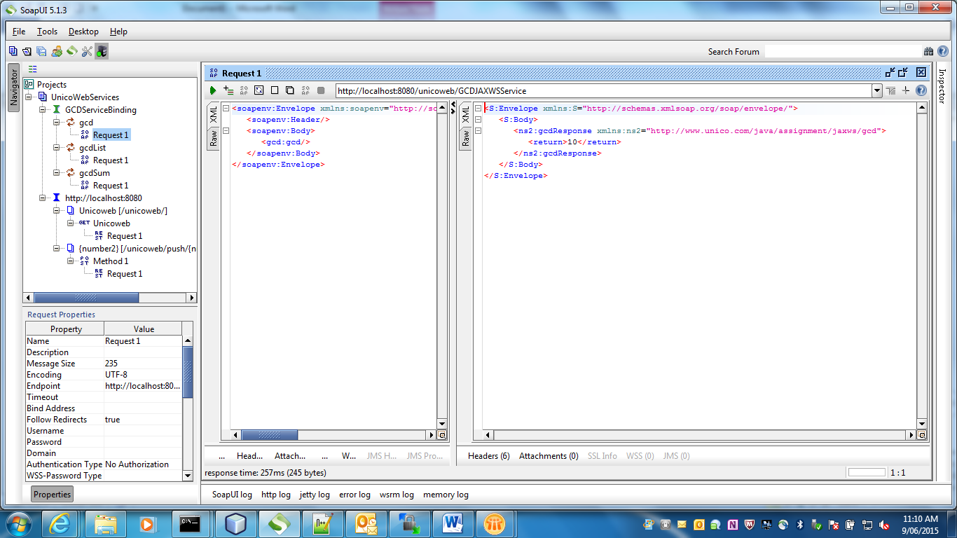

ActiveMQ console can be monitored to check integer messages have been consumed by SOAP service

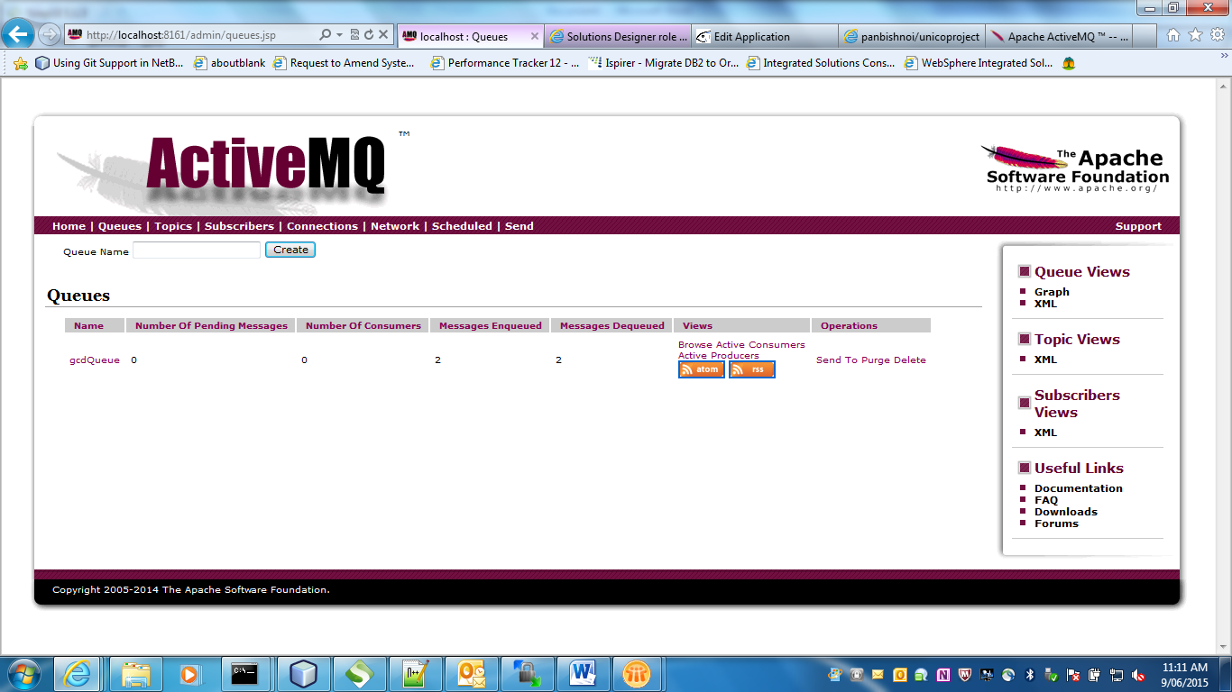

## GCD List

This operation returns list of GCD calculated from GCD table

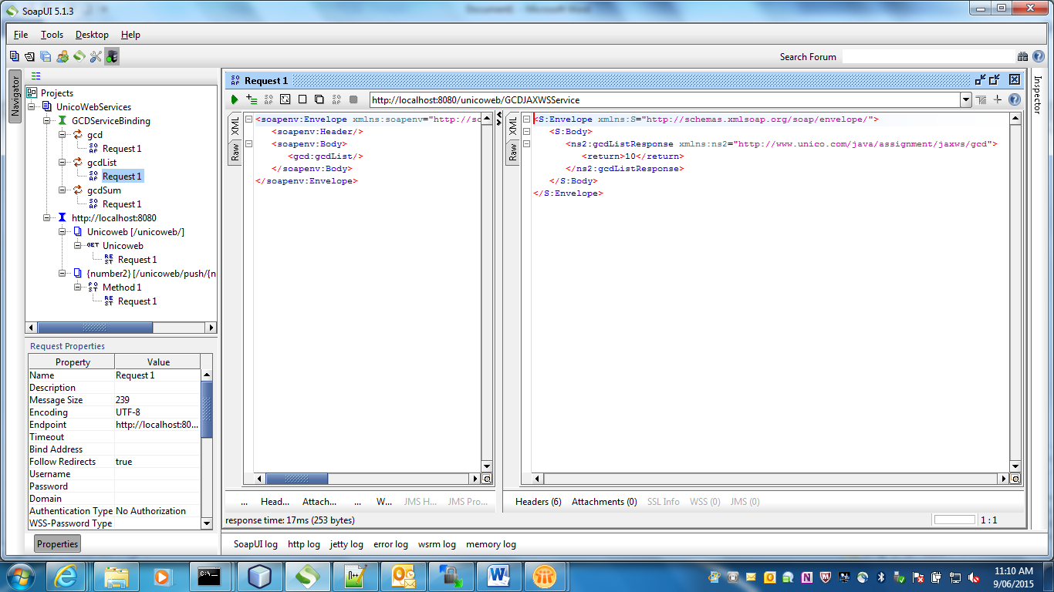

## GCDSum

Returns sum of calculated GCD

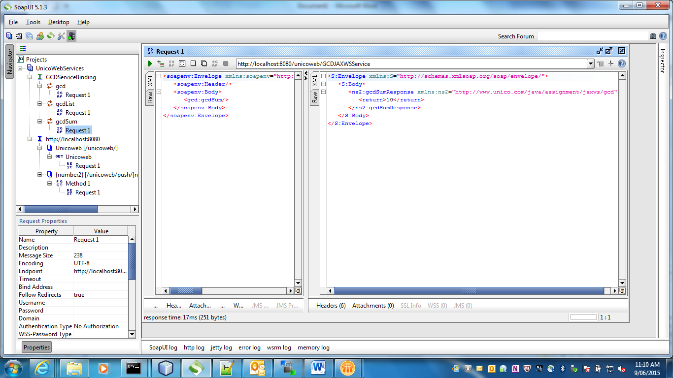

# Load Testing

Load testing with 20 threads in SOAPUI.

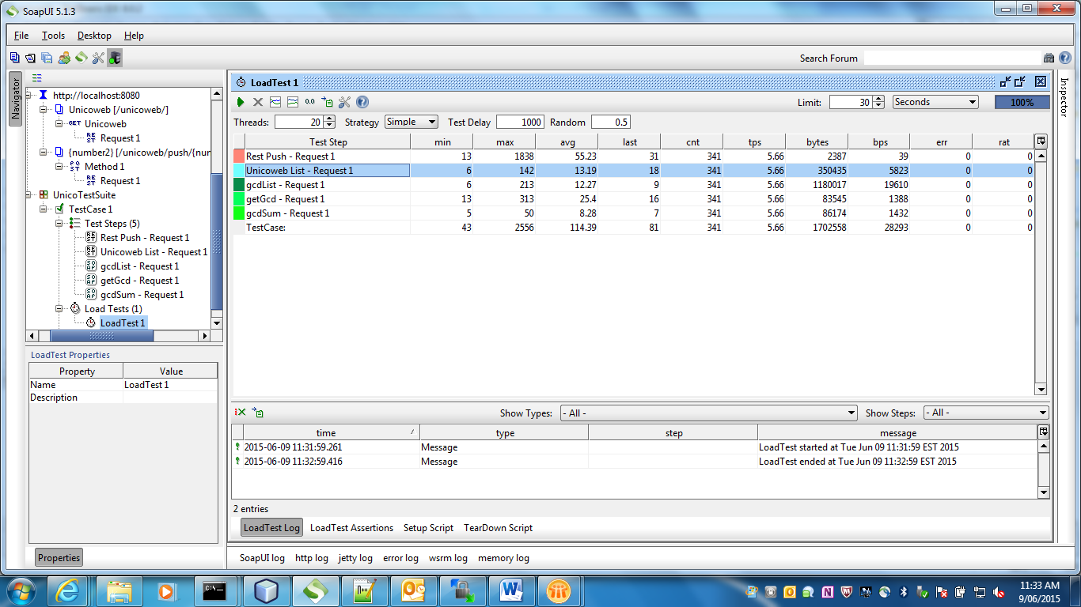

JMS Stats post test run

